Crypt Arithmetic Problem Using Python

Aim
To develop a Python program that solves a Crypt Arithmetic (Cryptarithmetic) problem by assigning unique digits to letters such that the given arithmetic equation is satisfied while ensuring that no two letters have the same digit and no leading letter is assigned zero.

Objective
To solve a Crypt Arithmetic (Cryptarithmetic) problem using Python by assigning unique digits to letters so that the arithmetic equation is satisfied.

Algorithm
- Start.
- Define the crypt arithmetic equation (e.g., SEND + MORE = MONEY).
- Extract all unique letters from the equation.
- Generate all possible digit assignments (0–9) for the letters.
- Ensure that no leading letter is assigned the digit 0.
- Convert each word into its corresponding numeric value.
- Check whether the arithmetic equation is satisfied.
- If a valid solution is found, display the mapping and the numbers.
- Stop.
Flowchart
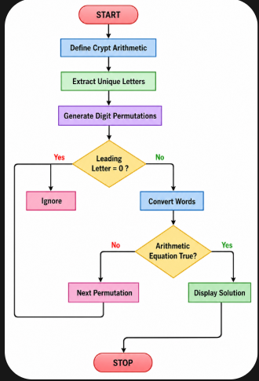
CODE:
from itertools import permutations

# Crypt Arithmetic: SEND + MORE = MONEY

letters = ('S', 'E', 'N', 'D', 'M', 'O', 'R', 'Y')

digits = range(10)

for perm in permutations(digits, len(letters)):
S, E, N, D, M, O, R, Y = perm

# Leading digits cannot be zero
if S == 0 or M == 0:
continue

SEND = 1000*S + 100*E + 10*N + D
MORE = 1000*M + 100*O + 10*R + E
MONEY = 10000*M + 1000*O + 100*N + 10*E + Y

if SEND + MORE == MONEY:
print("Solution Found!")
print("----------------")
print("S =", S)
print("E =", E)
print("N =", N)
print("D =", D)
print("M =", M)
print("O =", O)
print("R =", R)
print("Y =", Y)

print("\nSEND =", SEND)
print("MORE =", MORE)
print("MONEY =", MONEY)
break
output:
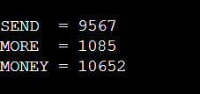
Result:
The Crypt Arithmetic problem SEND + MORE = MONEY was successfully solved using Python. The program correctly assigned unique digits to each letter while satisfying all constraints, producing the valid solution:
Conclusion:
The Python program successfully solves the Crypt Arithmetic problem by using permutation-based backtracking. It ensures that each letter is assigned a unique digit, leading letters are not assigned zero, and the arithmetic equation is satisfied. This experiment demonstrates the application of combinatorial search and constraint satisfaction techniques in Python.

